Florida A & M University Board of Trustees
Emergency Full Board Meeting

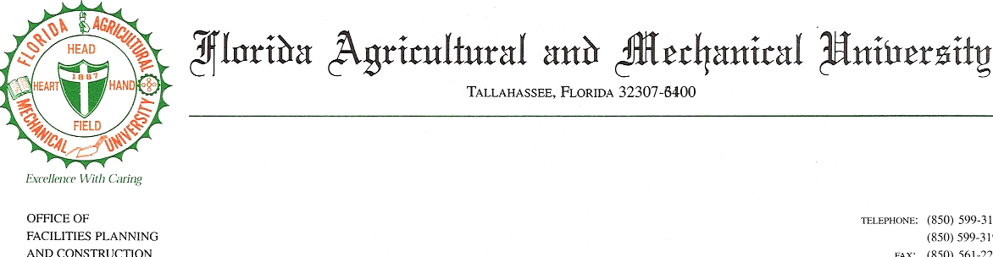
Teleconference Meeting

April 9, 2007

1:00– 2:00 p.m.
Agenda
Trustee Challis Lowe, Chair

- Call to Order Chair Lowe
- Roll Call

- Approval of Agenda

- College of Engineering
- Accreditation
    - College of Law
    - College of Pharmacy

6. Summer School

7. Employee Health Insurance

8. Adjournment

CALL-IN NUMBER: 1-800-356-6464
CONFERENCE ID#: 4974739

